­



A PROJECT REPORT

“EMPLOYEE MANAGEMENT SYSTEM”

SUBMITTED BY

SAI KUMAR MOPURU

[Saikumarmopur321@gmail.com](mailto:Saikumarmopur321@gmail.com)

+91-8897845598

**INDEX**

TABLE OF CONTENTS

1. PROJECT DESCRIPTION

* Introduction
* Scop of Project
* Objective of Project
* Purpose of project

1. EXISTING SYSTEM
2. PROPOSED SYSTEM
3. SYSTEM REQUIREMENTS
4. MODULES
5. SOFTWARE DESIGN

* Administator
* Employee
* EMS

7.ADVANTAGES

8.FEATURES

9.LIMITATIONS

10.FUTURE MODIFICATIONS

11.CONCLUSION

**PROJECT DESCRIPTION**

**Objective of java and MySql project on Employee Management System :-**

The main objective of the java and Mysql project on Employee Management is to manage the details of information, leaves, salary, login, employee. It manages all the information about information, experience, employee, information. The project is totally built at administrative and thus only administrator is guaranteed the access. The purpose of the project is to build an application program to reduce the manual work for managing the information, leaves, salary. It tracts all the details about the salary, login, employee.

Functionalities provided by java and Mysql on Employee Management system are as follows:

1. Provides the searching facilities based on various factors. Such as information, salary, Login, Employee.
2. It tracks all the information of leaves, Login etc.
3. Manage the information of leaves
4. Shows the information and description of the information, Salary
5. Modifying the employee information.
6. To increase efficiency of managing the information, leaves
7. Editing, adding and updating of records is improved with result in proper resource management of information of data.
8. Manage the information of login.
9. Integration of all records of employee.

Input Data and Validation:

1. All the fields such as Salary, Employee and leaves are validated and don’t take invalid arguments.
2. Each form like Employee, Salary don’t take blank value.
3. Avoiding errors in data.
4. Controlling amount of input.

**­­­­­­­­­­­­­­­­­­**

**Introduction**

The employee management system manages and maintains the employee’s information such as the employee’s name, address, date of joining, and other details. So, the application manages leave management, attendance management, etc.

All the information that is in the Employee Management System can be all the employees [working in the organization](https://www.worker-management.com/what-is-the-manager-employee-experience-job-description/) using the system. Also, it can be controlling all the company-related information from anywhere around the world without any issues.

The Employee Management System is a cloud-based software and it has many applications. Such as attendance management applications, leave management applications, salary calculation applications, etc.

**SCOPE OF THE PROJECT**

For all the s/w there is always a scope of future enhancements. There are few enhancements which are pointed out in the proposed system. There are as follows

1. Module for Employee Loan.
2. Modules for proper arrangement of attendance of employees.
3. Introducing online version of the Software.
4. Introducing Software for Employee side also.
5. More proper salary calculations based on version factors.

**OBJECTIVE OF THE PROJECT**

* Time and Cost Effective – Software is making the process of keeping database time and effective by making it easy to alter or update database and also keeping the safe.
* Database Creation – A database of the registered users will be created and this will help the user to fetch the details of Computer Centre.
* Flexibility – Database provides flexibility to administrator. Record can be insert, delete or updated with just a click.
* Informative – The software has all the necessary details about the Students and Course and provides all the relevant information therefore. For example, searching of appropriate Student for like admission and then the information of admission is added to Student records.
* Security – Proper authorization and authentication provisions have been made for the security of the software so that only the registered administrators can look the information . Without proper login no one is allowed to access this software.

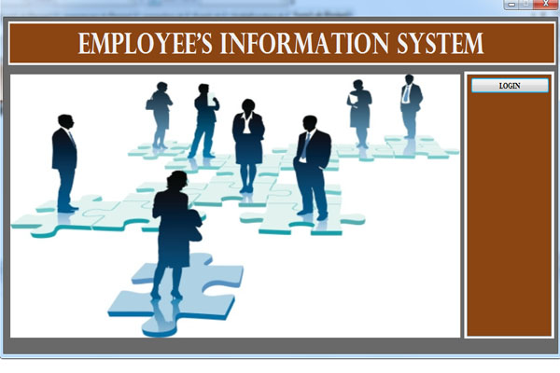

**LOGIN PAGE:**

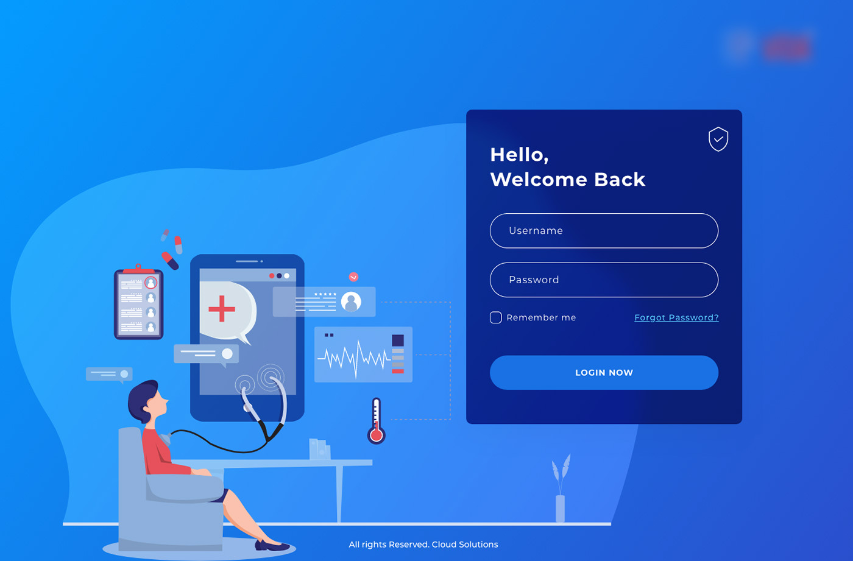

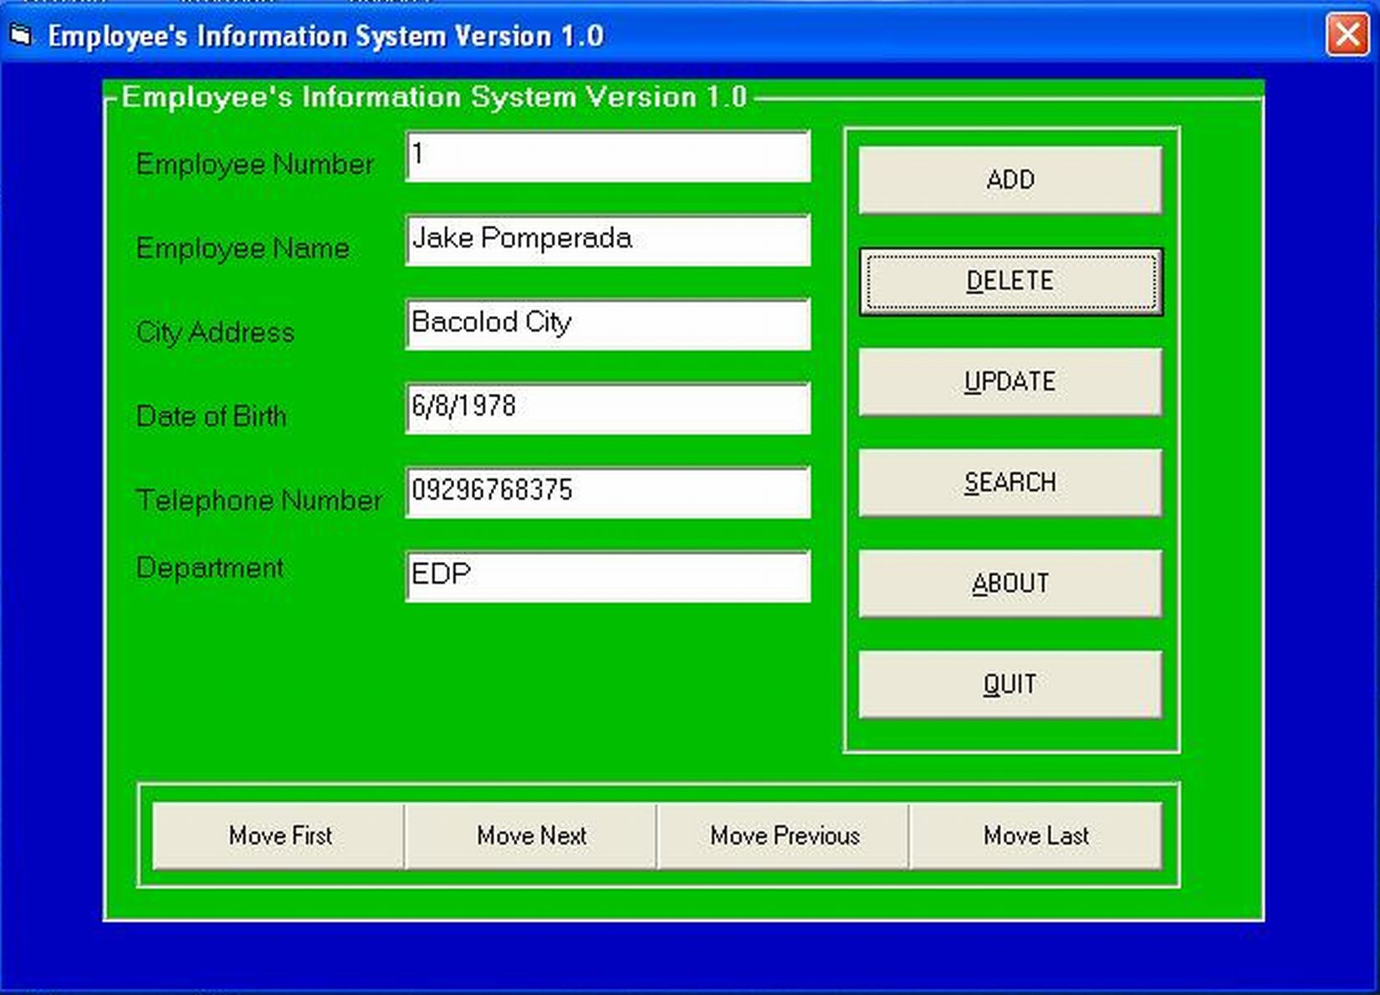

**EXISTING SYSTEM**

* The records are maintained in registers.
* Time consuming process.
* Complicated searching, editing & updating.

**PROPOSED SYSTEM**

* Helps in maintaining the computerized employee details.
* Calculate the salary
* Easy attendance marking.
* Easy calculation of various leave in categories.
* Computerized events & requests management.
* Create new users to the system accordingly.

**SYSTEM REQUIREMENTS**

HARDWARE REQUIRED:

* Processor- Ryzen7 or I7
* RAM -4GB
* Hard Disk-50GB
* Input Device -Keyboard, Mouse
* Output Device- Monitor Laptop

SOFTWARE REQUIRED:

* Platform – Windows XP through Windows
* Application Tool- Microsoft Visual Studio, Eclipse and Mysql.

**MODULES**

A Employee’s Management System (EMS) is a software built to handle the primary housekeeping functions of a company. EMS help companies keep track of all the employees and their records. It is used to manage the company using computerized system.

Aim of Employee’s Management System:

* Built The Employee Table.
* Insert New Entries.
* Delete The Entries.
* Search A Record.

Data of the Employee’s:

* Name
* Employee ID
* Designation
* Experience
* Age

**SOFTWARE DESIGN**

**JAVA:**

Java is a popular programming language, created in 1995.

It is owned by Oracle, and more than **3 billion** devices run Java.

It is used for:

* Mobile applications (specially Android apps)
* Desktop applications
* Web applications
* Web servers and application servers
* Games
* Database connection
* And much, much more!
* Java works on different platforms (Windows, Mac, Linux, Raspberry Pi, etc.)
* It is one of the most popular programming language in the world
* It has a large demand in the current job market
* It is easy to learn and simple to use
* It is open-source and free
* It is secure, fast and powerful
* It has a huge community support (tens of millions of developers)
* Java is an object oriented language which gives a clear structure to programs and allows code to be reused, lowering development costs

**MYSQL:**

A database is a separate application that stores a collection of data. Each database has one or more distinct APIs for creating, accessing, managing, searching and replicating the data it holds.

Other kinds of data stores can also be used, such as files on the file system or large hash tables in memory but data fetching and writing would not be so fast and easy with those type of systems.

Nowadays, we use relational database management systems (RDBMS) to store and manage huge volume of data. This is called relational database because all the data is stored into different tables and relations are established using primary keys or other keys known as **Foreign Keys**.

A **Relational DataBase Management System (RDBMS)** is a software that −

* Enables you to implement a database with tables, columns and indexes.
* Guarantees the Referential Integrity between rows of various tables.
* Updates the indexes automatically.
* Interprets an SQL query and combines information from various tables.

Approach:

* For storing the data of the employee, create a user define datatype which will store the information regarding Employee. Below is the declaration of the data type:

struct employee {

string name,

long int code,

string designation,

int exp,

int age

};

Building the Employee’s table: For building the employee table the idea is to use the array of the above struct datatype which will use to store the information regarding employee. For storing information at index i the data is stored as:

struct employee emp[10];

emp[i].name = "skill-lync";

emp[i].code = "12345";

emp[i].designation = "Organisation";

emp[i].exp = 10

emp[i].age = 10

Deleting in the record: Since we are using array to store the data, therefore to delete the data at any index shift all the data at that index by 1 and delete the last data of the array by decreasing the size of array by 1.

Searching in the record: For searching in the record based on any parameter, the idea is to traverse the data and if at any index the value parameters matches with the record stored, print all the information of that employee.

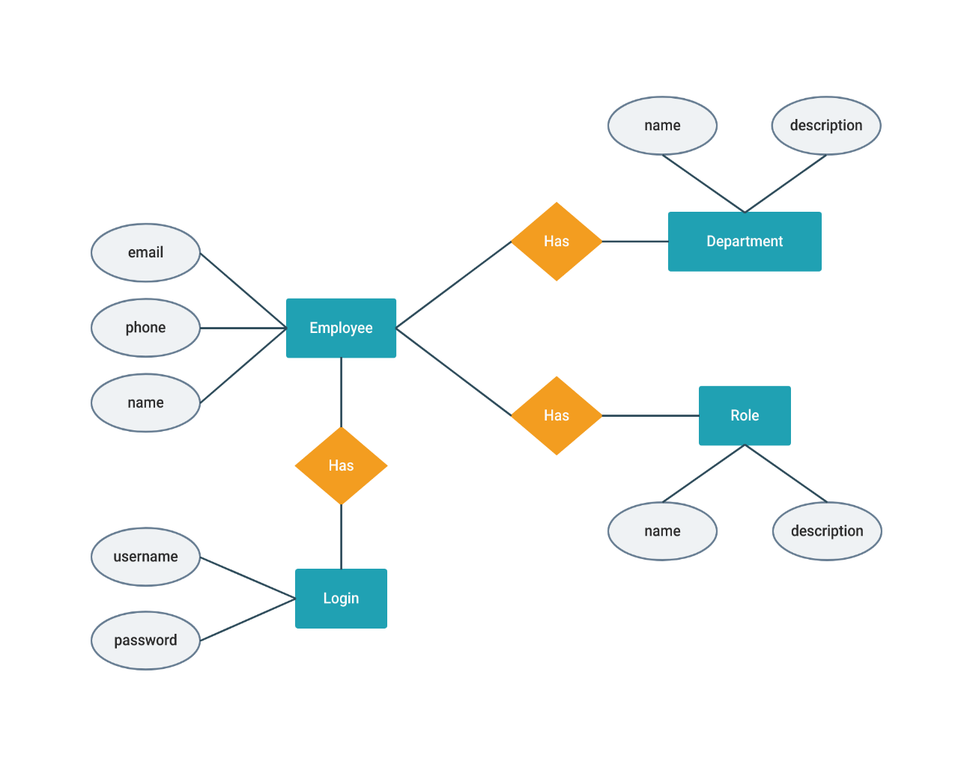

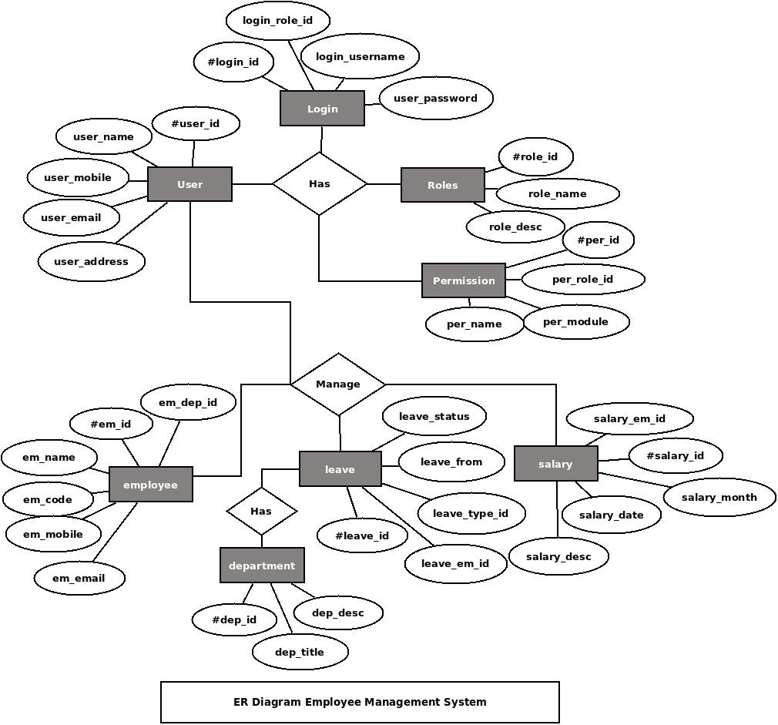

ADVANTAGES

* Provide computerized system for maintaining records
* More efficient & reliable
* Less time consuming and easy to use
* Huge data storage with less computer memory
* Avoid human errors & efforts for maintaining daily data.
* Avoid data manipulations
* Also avoids data inconsistency & redundancy

FEATURES

Key features that an effective system should include:

* Time and attendance management
* Mobile workforce management
* Absence and leave management
* Employee database management
* Online backup facility

LIMITATIONS

* Description of events has to be added repeatedly
* Salary is not being deducted for leaves.
* No overtimes are paid either.
* Two forms for attendance
* This software provides with the simple working to the users. Complex outcome & demands can not be satisfactorily fulfilled to the users.

FUTURE MODIFICATIONS

* This project can be modified in future according to the need of the employee, administrator and user.
* This project can be used not only as the information system but as the management system also only by including some more management features and modifications.
* This project can also be made to work online by providing the internet feature and hence can be changed to work as an Only job Portal.

CONCLUSION

A**User-Friendly Employee Management System An employee management system can streamline and automate a company’s human resources tasks**. It, thus, eliminates the need to manually and tediously go through the employee management process, which helps save a lot of time and energy.